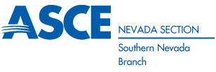

NOMINATION FORM

ASCE SOUTHERN NEVADA BRANCH
2018 – 2019 BOARD OF DIRECTORS

Please return nominations to Joe Cetrulo by 5:00 pm on Friday, July 20, 2018 via email at

E-mail: jcetrulo@gcwengineering.com

Nominee’s Name: ______________________________________________________

Nominee’s ASCE Member Number: _________________________________________

Position: ______________________________________________________________

Phone: _________________________ E-mail: ___________________________

Please provide a brief background/description of the nominee:

________________________________________________________________________________________________________________________________________________________________________________________________________________________________________________________________________________________________________________________________________________________________________________________________________________________________________________________________________________________________________________________________________________________________________________________________________________________________________________________________________________________________________________________________________________________________________________________________________________________
________________________________________________________________________________________
________________________________________________________________________________________
________________________________________________________________________________________

